Part 8

Building on the differentially expressed gene set from part 7, we investigated these genes further by constructing a connected protein-protein interaction (PPI) network. UniProt accession IDs corresponding to the selected 49 genes were submitted to the STRING (Homo sapiens) database (v12.0). Known and predicted functional associations were retrieved after successful mapping of submitted UniProt identifiers. The resulting interaction network was imported into Cytoscape and visualized using a force-directed layout to emphasize connectivity patterns between highly interacting proteins. We integrated the differential expression information by mapping logFC values onto the network. Additionally, node size was scaled based on protein length such that longer proteins were represented by smaller nodes.

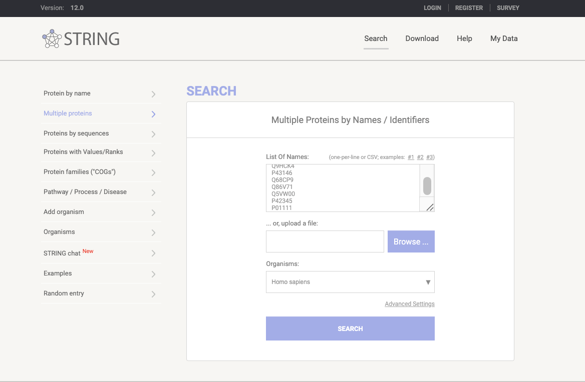
Figure X. String input for protein-protein interaction analysis

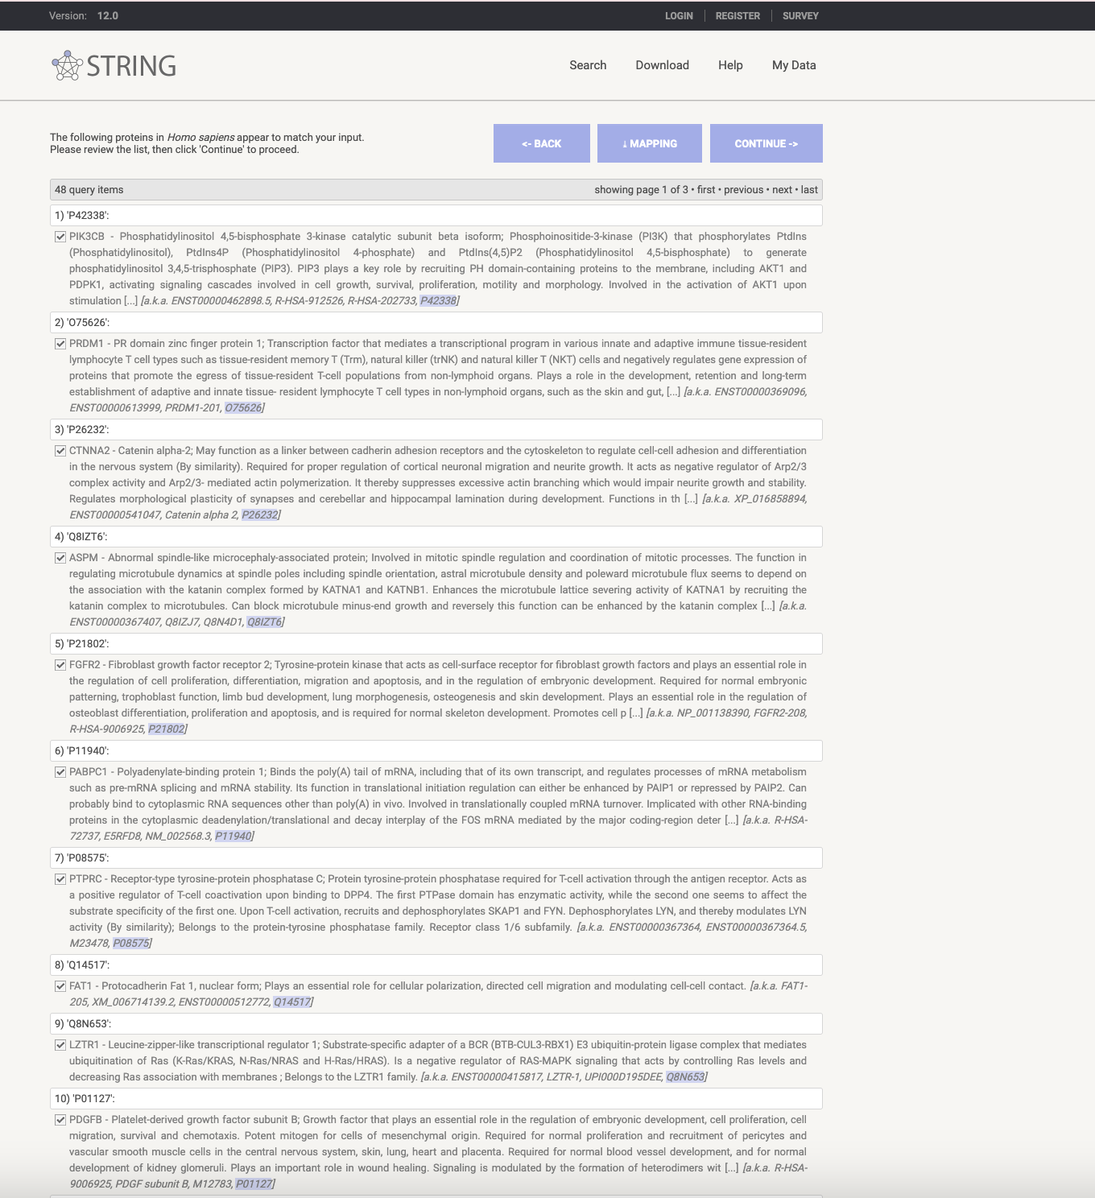
Figure X. Mapping of UniProt Identifiers in STRING
STRING successfully matched 48 genes to Homo sapiens entries from the list submitted.
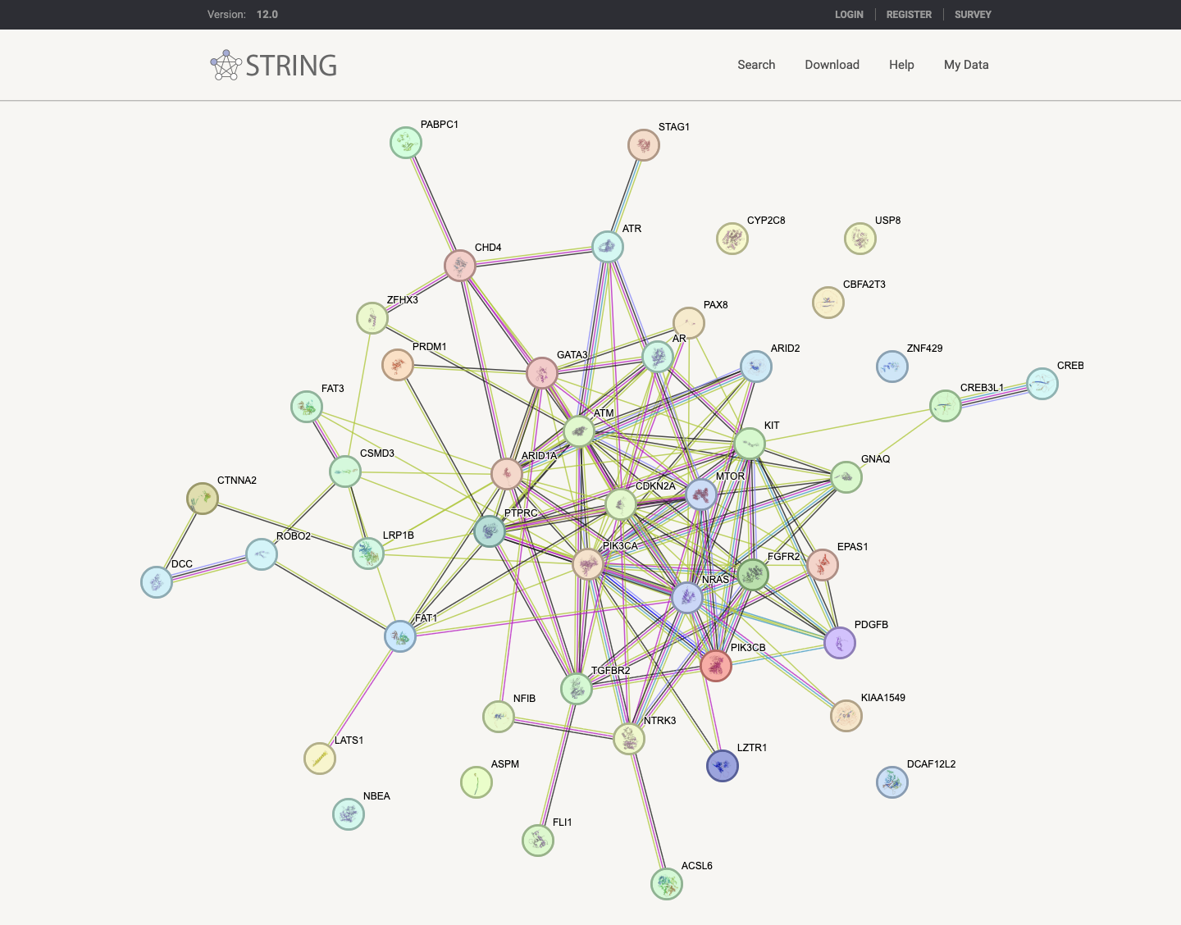
Figure X. STRING derived protein-protein interaction network

Nodes represent proteins and edges represent functional associations supported by experimental evidence, curated databases, co-expression, in addition to computational predictions. The network above highlights interaction hubs and connectivity patterns from the gene set before downstream analysis and functional annotation in Cytoscape.
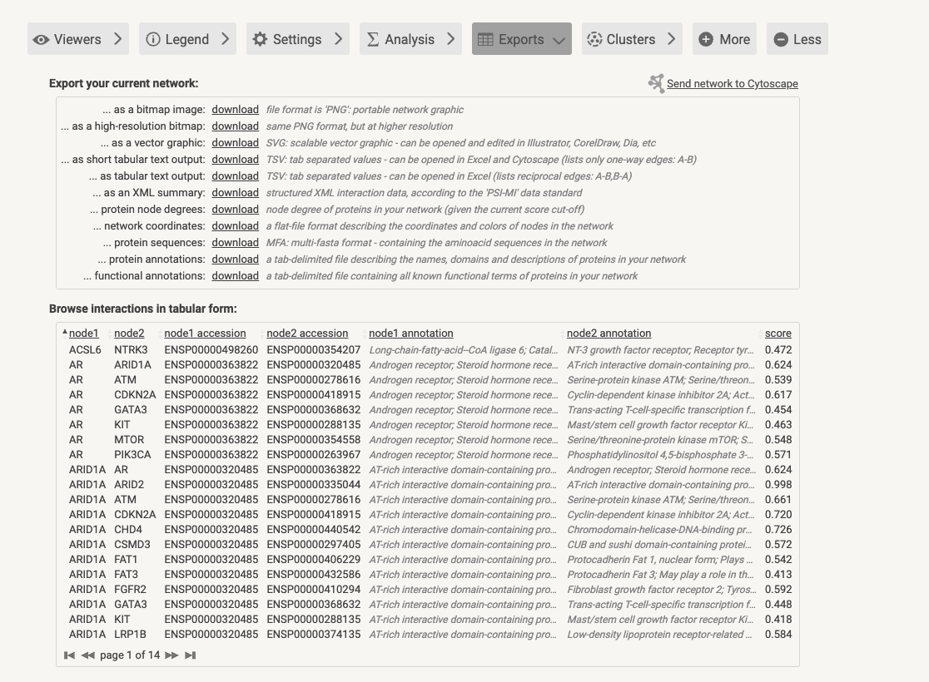

Figure X. Export of STRING protein-protein interaction data in tabular format (short tabular text output)
This table lists interacting protein pairs, corresponding accession identifiers, functional annotations, and interaction confidence scores.

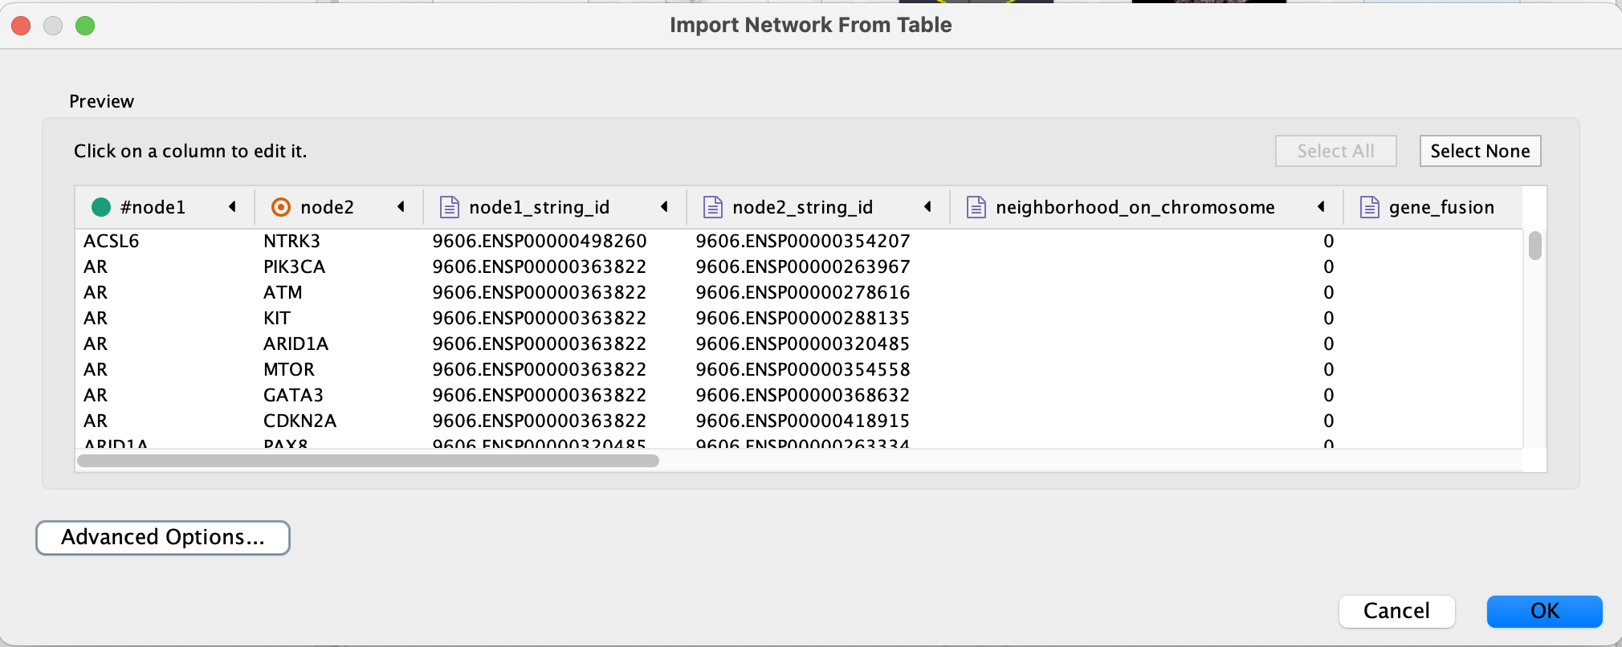

Figure X. Import of STRING interaction data into Cytoscape.
The protein-protein interaction table exported from STRING was imported into Cytoscape using the Import Network from Table function. Interactions were defined as source (node 1) and target (node 2) protein pairs.
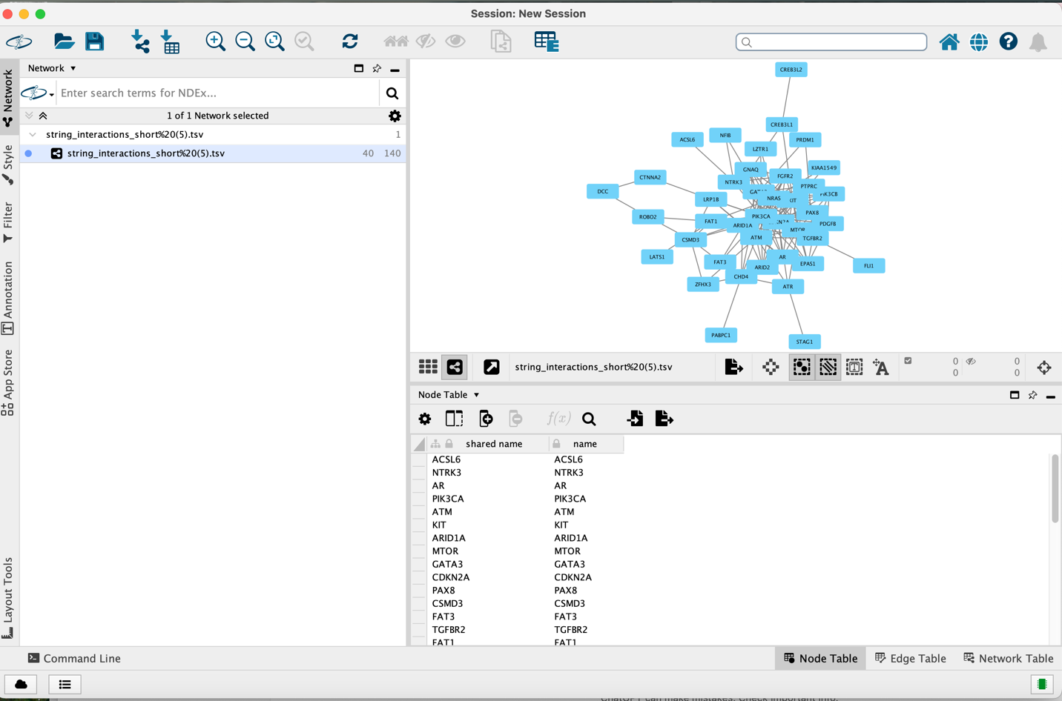
Figure X. Cytoscape visualization of the STRING derived protein-protein interaction network
Nodes represent proteins encoded by the differentially expressed genes from part 7 and the edges represent known or predicted functional associations obtained from STRING.

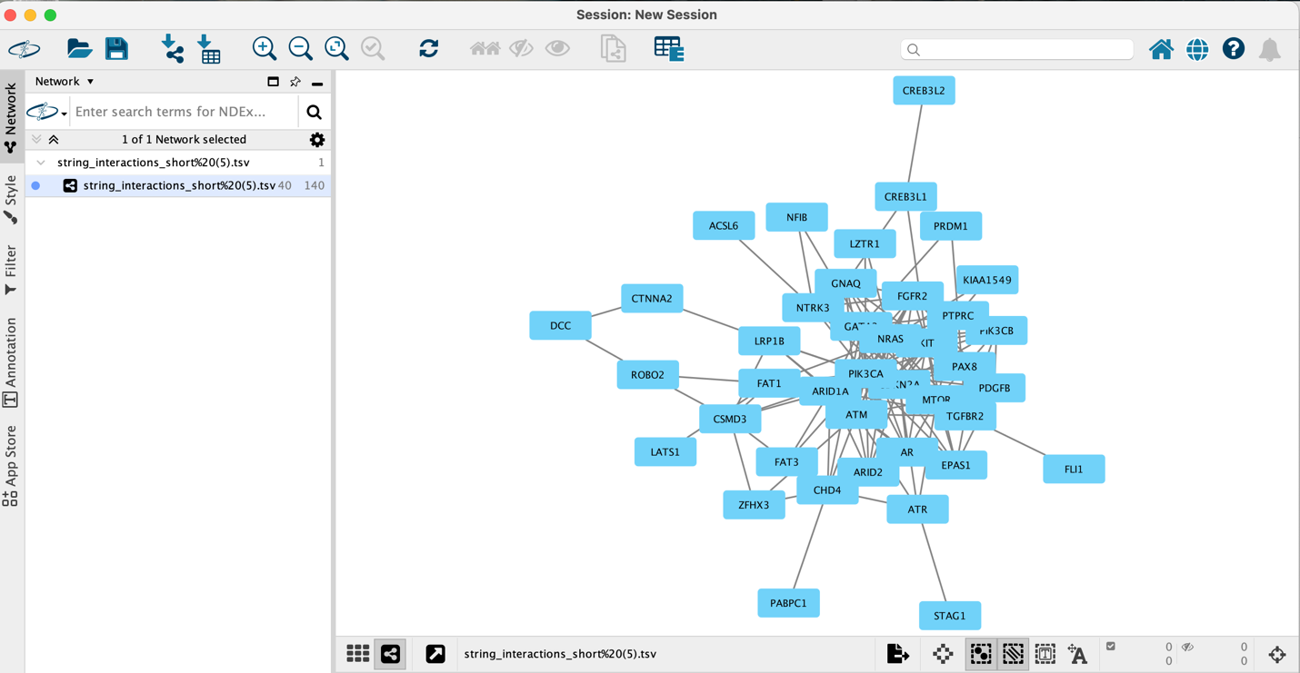
Figure X. Cytoscape visualization of the STRING derived protein-protein interaction network
Nodes represent proteins encoded by the differentially expressed genes from part 7 and the edges represent known or predicted functional associations obtained from STRING.

To improve the interpretation of the network, a force directed layout was applied to allow highly connected proteins to cluster in the center and less connected proteins to be positioned on the outside.
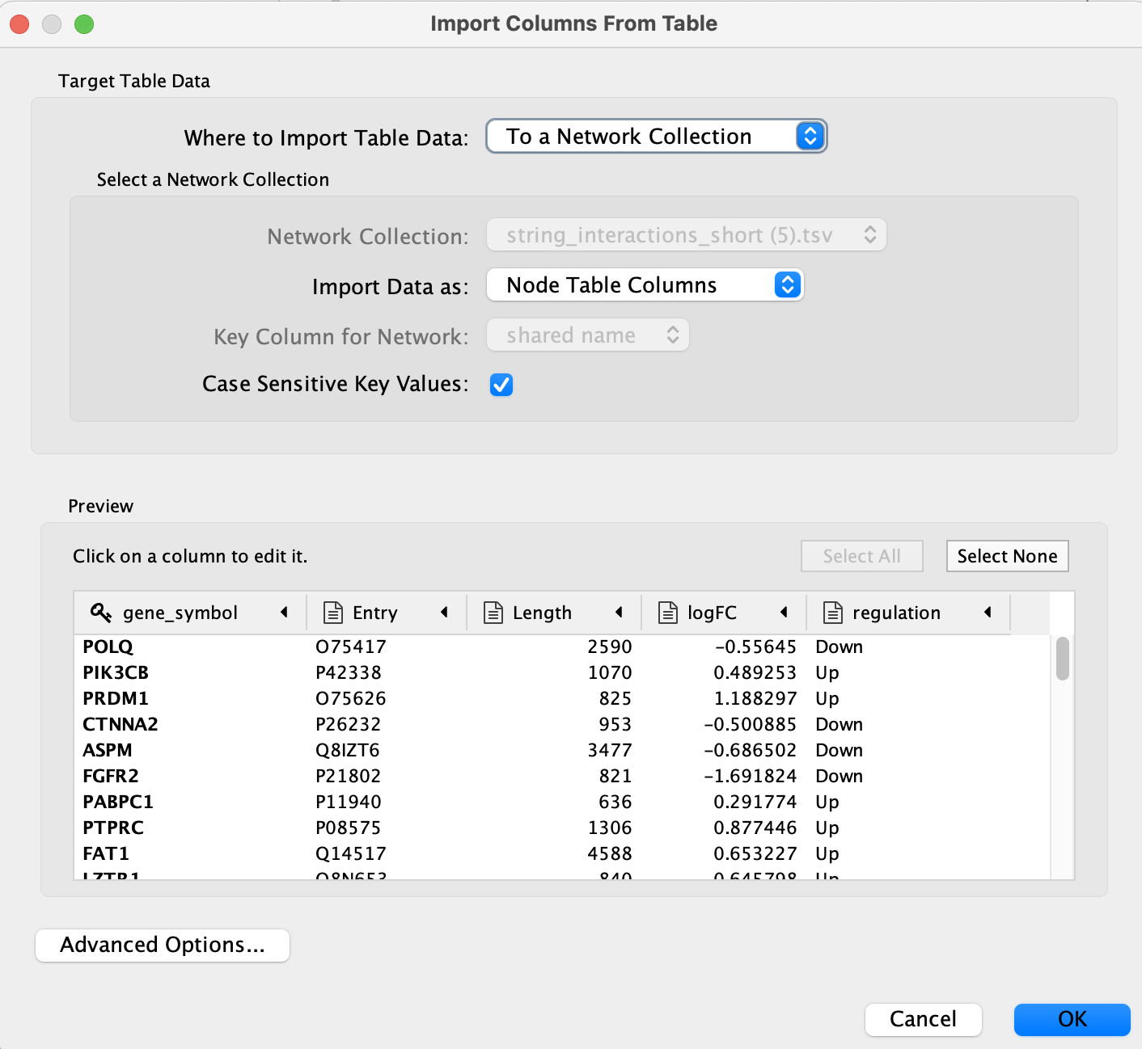
Figure X. Import of differential expression attributes into the STRING derived PPI network in Cytoscape

Differential expression attributes (gene symbol, UniProt entry, protein length, log fold change, and regulation status) were imported into Cytoscape as node table columns using the Import columns from Table function. Gene symbols were matched to the existing network nodes through the shared name key to ensure correct attribute mapping.

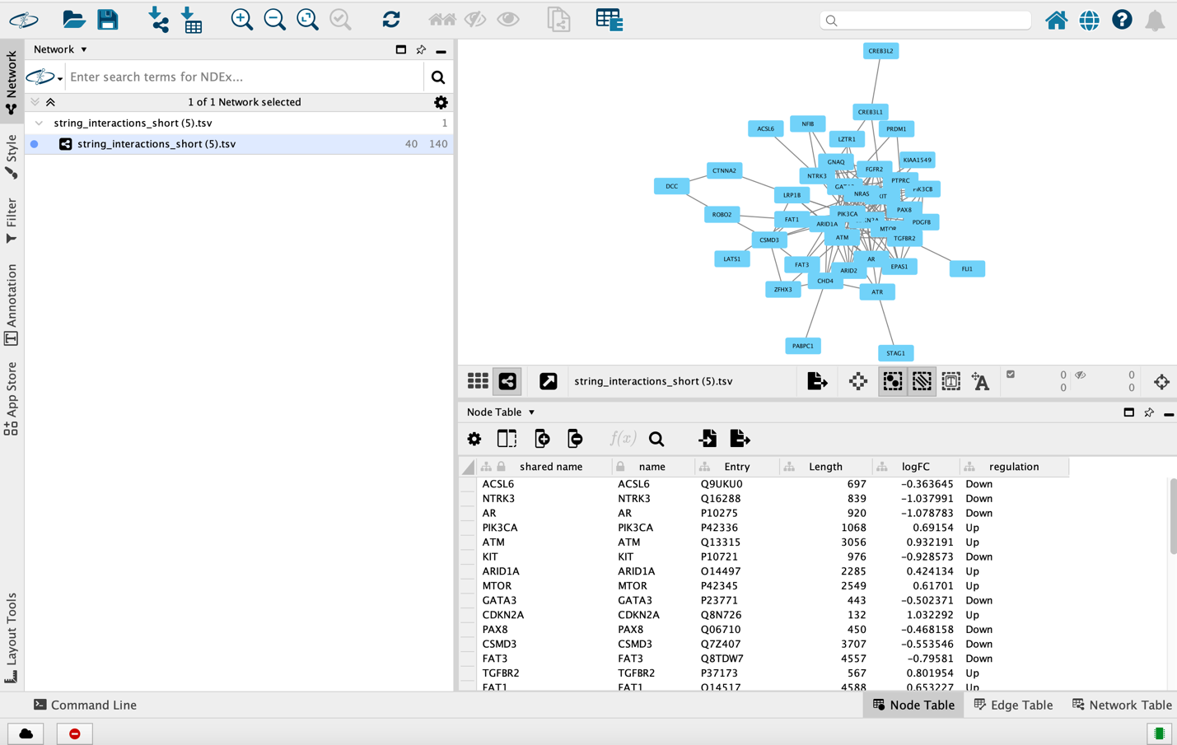
Figure X. Final integrated Cytoscape Network

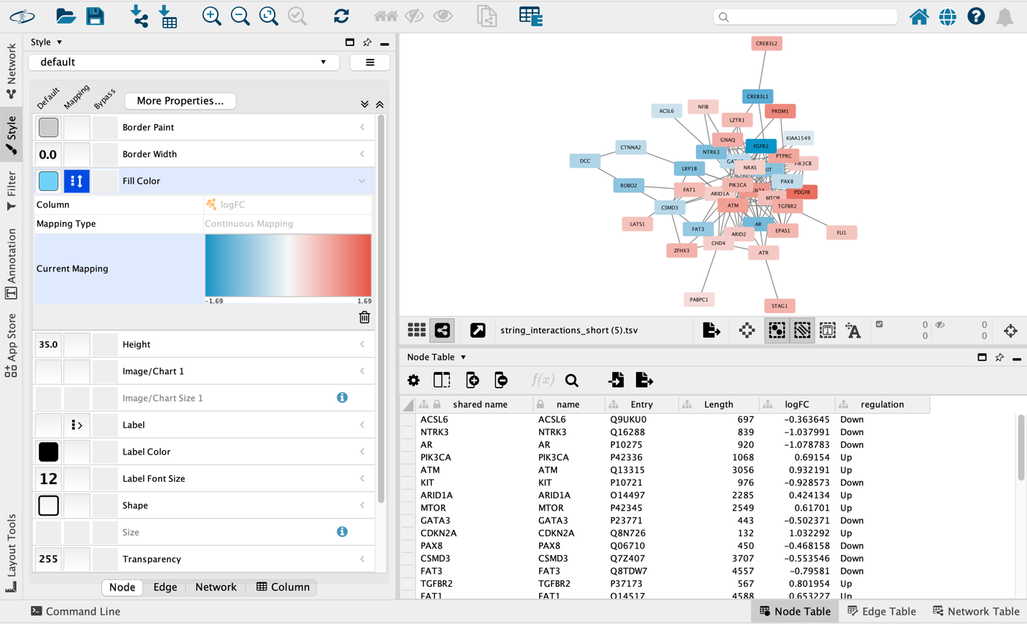
Figure X. Visualization of differential gene expression in the PPI network using log fold change (logFC)
Node fill color represents the logFC values from the differential expression analysis, with red indicating upregulated genes and blue indicating down regulated genes. Color intensity reflects the magnitude of expression change.
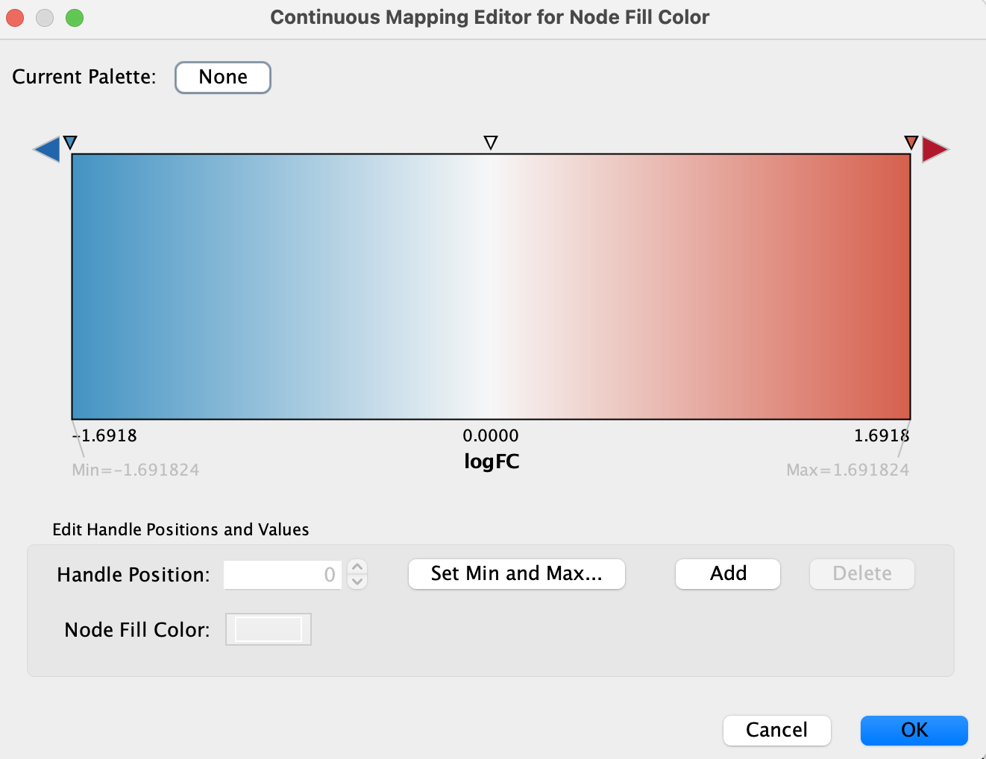
Figure x. Continuous color mapping used for log fold change visualization in the PPI network

Node fill colors were mapped to logFC values using a zero centered continuous gradient, with blue indicating negative logFC (downregulation), white represents no change, and red indicating positive logFC. The scale ranges from -1.69 to +1.69.
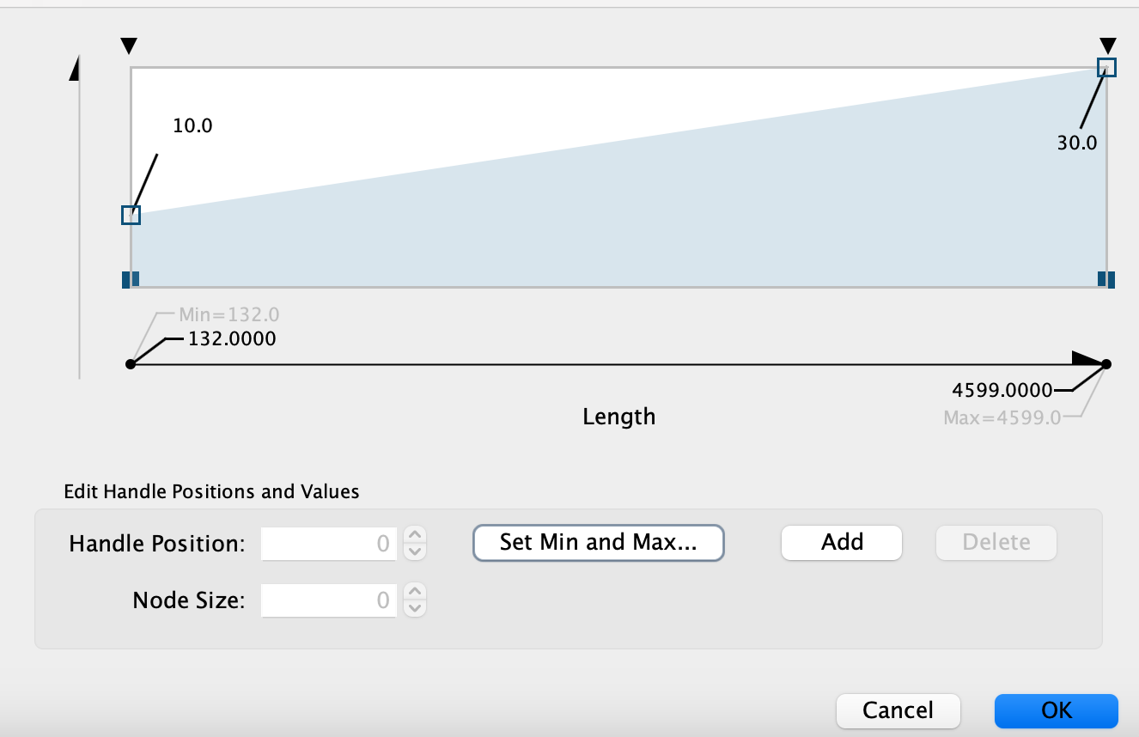

Figure X. Continuous node size mapping based on protein length

Node size was mapped to protein length using a continuous scale with node sizes ranging from 10 to 30. Smaller nodes represent longer proteins. Longer proteins are shown as larger nodes. The protein length ranges from 132 (minimum) to 4599 (maximum) amino acids.

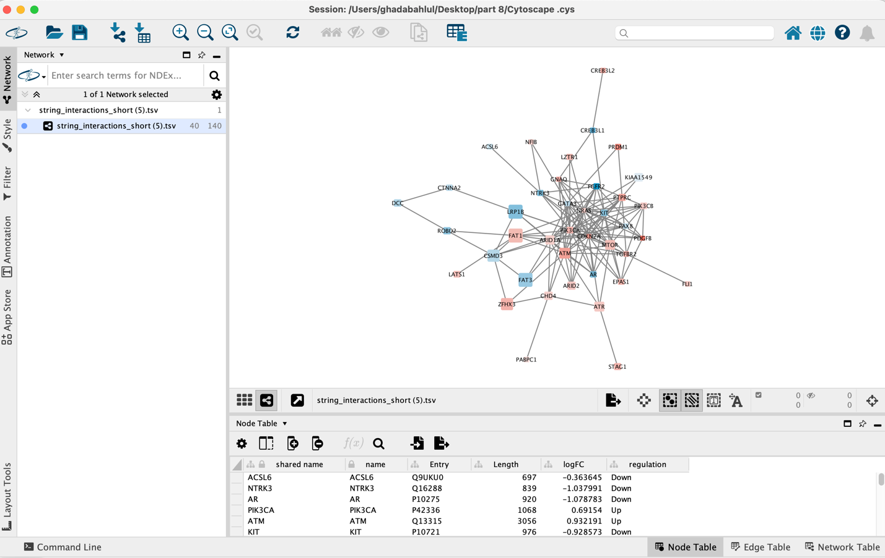
Figure X. Protein-protein interaction network with expression and protein length annotations

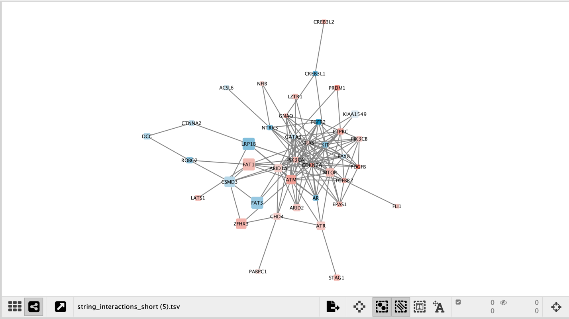
Figure X. Fully integrated protein-protein interaction (PPI) network visualization in Cytoscape.
This network represents known and predicted functional associations among differentially expressed genes from STRING. Nodes correspond to proteins and edges represent STRING supported interactions. Node color reflects differential expression (logFC), and node size is scaled according to protein length.

